GRAPHICS AND ANIMATION TOOLS
LAB
VIVA-2
DESIGN A SNOW MOUNTAIN

Step – 1:

Open Blender and remove the pre-existing objects from the screen and turn off the camera option from View dropdown menu besides the OVERLAY menu.
Step – 2:

Go to prefences in the EDIT menu to make sure the “Another Noice Tool-landscape” is selected.
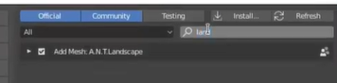

Step – 3:
Click ADD → MESH → Landscape.

Step – 4:
Adjust the mesh properties.

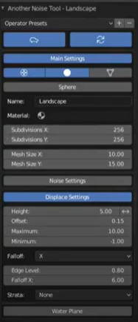
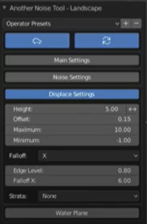
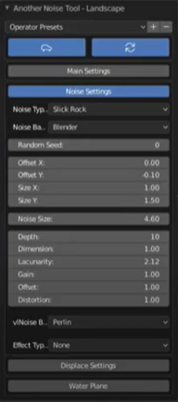

Step – 5:

Press SHIFT+F10 for the UV Editor window to open. Select the whole landscape and right click and select UNWRAP. Now press SHIFT+F9 to go to the OUTLINER.

Step – 6:

Split the window and open Shader Editor in one of them.
Change New to MATERIAL 001
Select Transparency(from world in properties) for the landscape in another window. Also select WORLD in the Shader Editor.
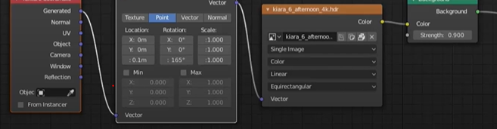
Step – 7:

Go to World Properties and:-
- Select Diffused BSDF in Surface Shader.
- Select terrain_color in Color option.
- And rest of the settings as shown below
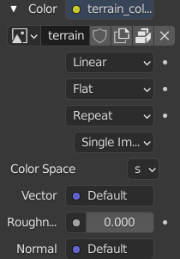
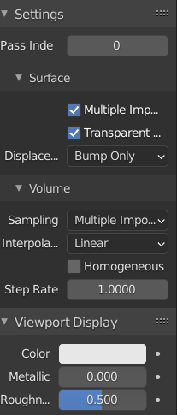
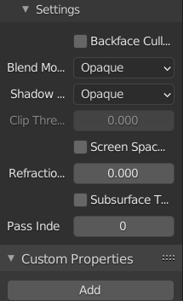

Final Output:-

